1. Pie Chart – Proportion of total sales by Category
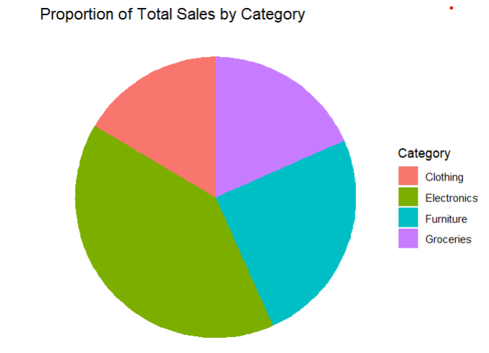
2. Stacked Bar Chart – Proportions by Month
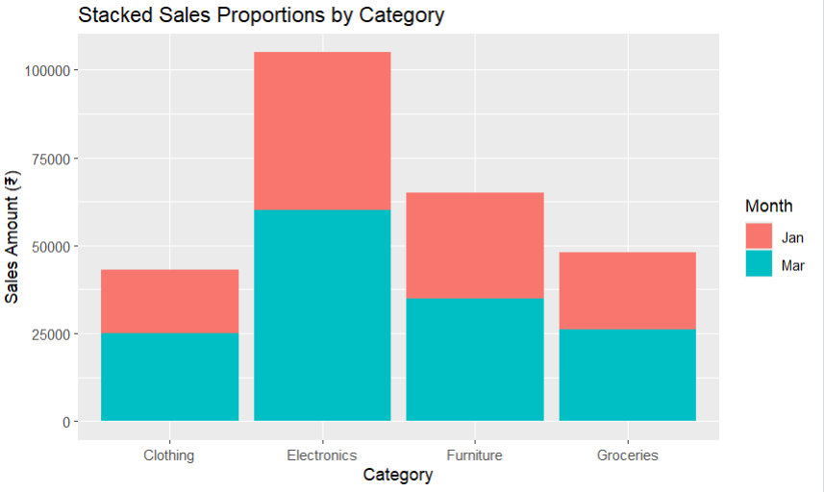

3. Treemap – Hierarchical proportions
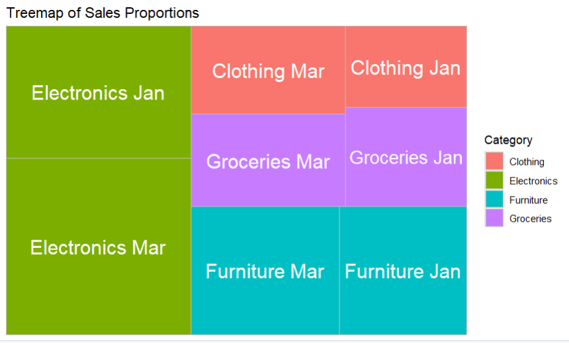

4. Sunburst Chart – Nested hierarchical proportions
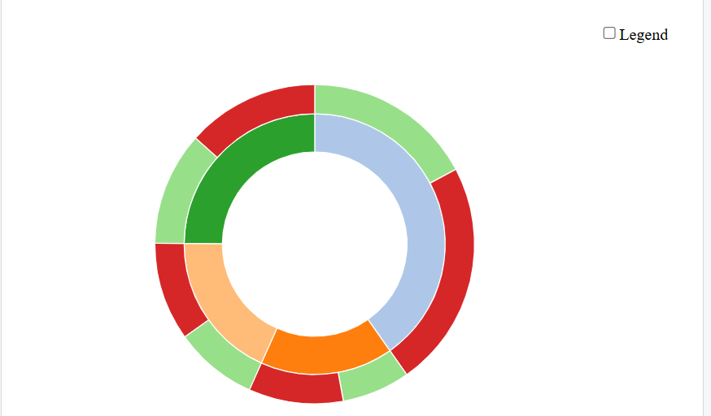

5. Parallel Sets – Compare categorical variables
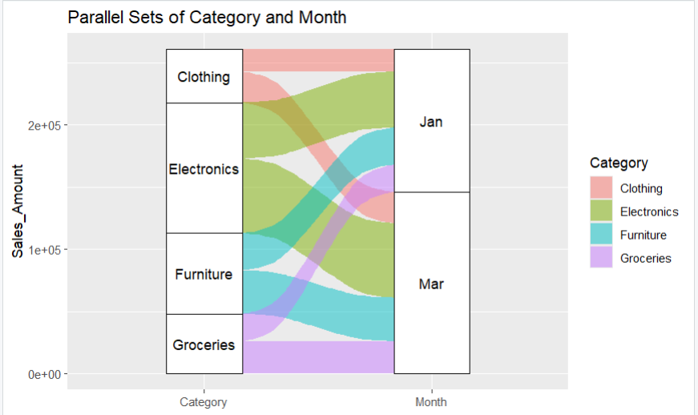

6. Sankey Diagram – Flow between Category and Month
